Coursework Submission Cover Sheet

Student ID (LMU ID)

Module Code and Name

Assessment No/Title

Assessment Submission Deadline

Module Leader

Academic Integrity and Plagiarism
You are reminded that there exist regulations concerning plagiarism. Extracts from these regulations are printed below. Please sign below to say that you have read and understand these extracts:
This header sheet should be attached to the work you submit. No work will be accepted without it.
Extracts from University Regulations on
Cheating, Plagiarism and Collusion
Section 2.3: "The following broad types of offence can be identified and are provided as indicative examples ….
- Cheating: including taking unauthorized material into an examination; consulting unauthorized material outside the examination hall during the examination; obtaining an unseen examination paper in advance of the examination; copying from another examinee; using an unauthorized calculator during the examination or storing unauthorized material in the memory of a programmable calculator which is taken into the examination; copying coursework.
- Falsifying data in experimental results.
- Personation, where a substitute takes an examination or test on behalf of the candidate. Both candidate and substitute may be guilty of an offence under these Regulations.
- Bribery or attempted bribery of a person thought to have some influence on the candidate's assessment.
- Collusion to present joint work as the work solely of one individual.
- Plagiarism, where the work or ideas of another are presented as the candidate's own.
- Other conduct calculated to secure an advantage on assessment.
- Assisting in any of the above.
Some notes on what this means for students:
- Copying another student's work is an offence, whether from a copy on paper or from a computer file, and in whatever form the intellectual property being copied takes, including text, mathematical notation and computer programs.
- Text Box Taking extracts from published sources without attribution is an offence. To quote ideas, sometimes using extracts, is generally to be encouraged. Quoting ideas is achieved by stating an author's argument and attributing it, perhaps by quoting, immediately in the text, his or her name and year of publication, e.g. " e = mc2 (Einstein 1905)". A references section at the end of your work should then list all such references in alphabetical order of authors' surnames. (There are variations on this referencing system which your tutors may prefer you to use.) If you wish to quote a paragraph or so from published work then indent the quotation on both left and right margins, using an italic font where practicable, and introduce the quotation with an attribution.
Please sign below to say that you have read and understand these extracts:
----------------------------- | Click or tap to enter a date.
Student Signature | Date

.
CS7050NM Artificial Intelligence
Problem Solving Using State-Space Search and Knowledge-Based Inference
Group Report and Individual Report

Table of Contents
Part A - Group Report
1. Introduction
2. State-Space Definition
3. Maze Representation in Python
4. Success Criteria
5. Breadth-First Search (BFS)
6. Cost Calculation
7. State-Space Visualization
8. Logical Theory Using First-Order Logic
9. Ground Facts
10. Universally Quantified Rules and Heuristics
11. Group Conclusion
Part B - Individual Report
1. Introduction
2. Dijkstra's Algorithm
3. Python Data Structures
4. Dijkstra Search Process
5. Dijkstra Success Criteria
6. Dijkstra Result and Visualization
7. Knowledge-Based Problem Solving
8. Forward Chaining and GMP
9. Knowledge Base
10. Inference Rules and Goal Statement
11. Execution Trace
12. Program Structure
13. Comparison and Conclusion
References

PART A - GROUP REPORT

1. Introduction
This report talks a solution to the given maze problem using state-space search and First-Order Logic (FOL) mechanisms. The maze contains five rows and six columns. The agent starts at node (0,0) and must reach the goal node (4,5) without crossing obstacle nodes. For the group task, Breadth-First Search (BFS) is selected as the blind or uninformed search algorithm because every valid movement has the same cost. The report also develops a logical theory to represent the same maze using ground facts and universally quantified rules.
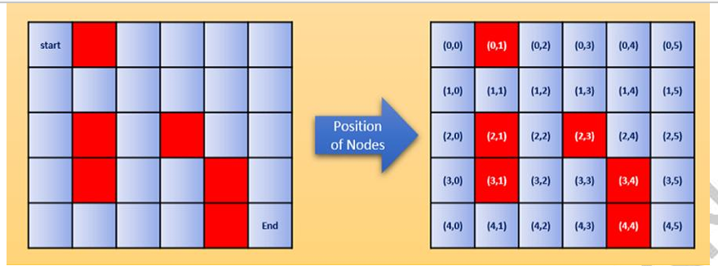
Figure 1 - Maze problem and coordinate representation

2. State-Space Definition
A maze is a very common state-space search problem. A state represents the current position of the agent. In this problem, each valid grid coordinate is treated as a state.
- State: a valid maze coordinate represented as (row, column).
- Initial state: (0,0).
- Goal state: (4,5).
- Actions: move Up, Down, Left or Right.
- Constraints: obstacle cells and positions outside the grid cannot be entered.
- Step cost: each valid movement has a cost of 1.

3. Maze Representation in Python
The maze is represented using simple Python data structures program. Tuples represent node coordinates, a set stores obstacle nodes, and a deque is used as the BFS frontier. Sets are suitable for obstacles and visited nodes because membership checks are efficient.
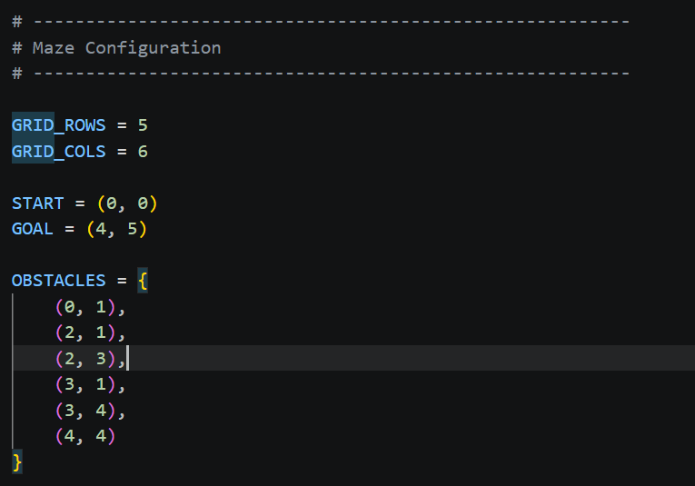
Figure 2 – Maze definition in Python Program

4. Success Criteria
The search succeeds when the node removed from the queue is the goal node. In program terms, the success test is:
if (curr_r, curr_c) == goal:
return path
The solution must start at (0,0), end at (4,5), remain inside the maze, jump only to adjacent nodes, and should never be entered to any obstacle node.
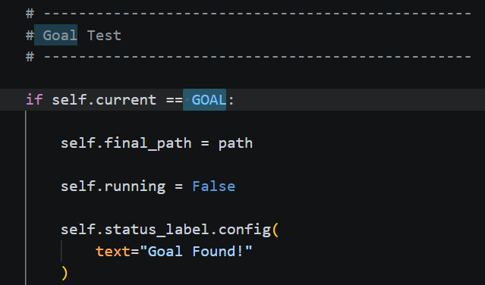
Figure 3 – Success criteria definition in python program

5. Breadth-First Search (BFS)
Breadth-First Search is an uninformed search algorithm. It explores nodes level by level and uses a FIFO (First In, First Out) queue method for searching. Since all movements in the maze have equal cost, BFS is appropriate for finding a shortest path in terms of number of moves. But it may not be the optimal algorithm.

5.1 BFS Program Logic
- Place the start node in the queue together with the path containing only the start node.
- Mark the start node as visited.
- Remove the oldest node from the queue using popleft().
- Test whether the current node is the goal.
- Generate valid successor nodes in the four allowed directions.
- Add each unvisited successor to the queue and record the extended path.
- Repeat until the goal is found or the queue becomes empty.

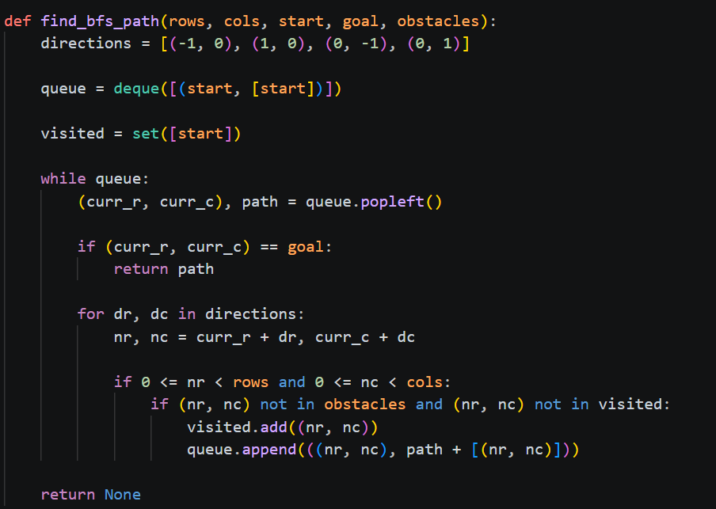
Figure 04 - Basic program for BFS (without visualization)

Visual Representation of BFS
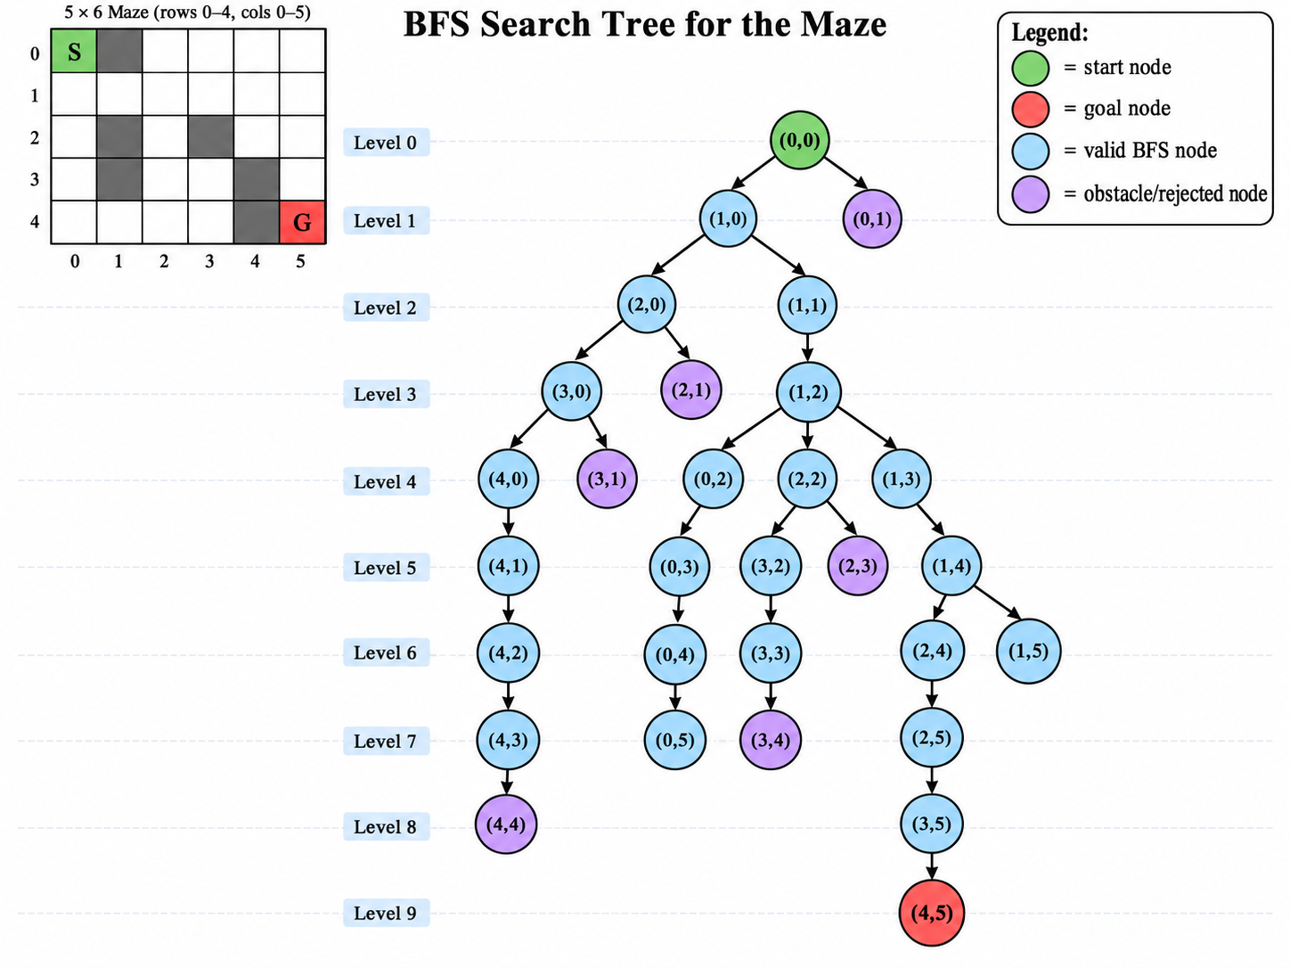
Figure 5 – Visual Representation of BFS Search Tree

Here is a simple, step-by-step explanation of BFS node exploration for the maze represent above.
Step 1 – Start at (0,0).
This is the start node.
Add (0,0) to the queue.
Mark (0,0) as visited.
Step 2 – Explore (0,0).
Check all possible directions: Up, Down, Left, Right.
(0,1) is an obstacle.
(1,0) is free.
Add (1,0) to the queue.
Step 3 – Explore (1,0).
Check nearby nodes.
(0,0) is already visited.
(2,0) is free.
(1,1) is free.
Add (2,0) and (1,1) to the queue.
Step 4 – Explore (2,0).
(1,0) is already visited.
(3,0) is free.
(2,1) is an obstacle.
Add (3,0) to the queue.
Step 5 – Explore (1,1).
(0,1) is an obstacle.
(2,1) is an obstacle.
(1,0) is already visited.
(1,2) is free.
Add (1,2) to the queue.
Step 6 – Explore (3,0).
(2,0) is already visited.
(4,0) is free.
(3,1) is an obstacle.
Add (4,0) to the queue.
Step 7 – Explore (1,2).
(0,2) is free.
(2,2) is free.
(1,1) is already visited.
(1,3) is free.
Add (0,2), (2,2), and (1,3) to the queue.
Step 8 – Explore (4,0).
(3,0) is already visited.
(4,1) is free.
Add (4,1) to the queue.
Step 9 – Explore (0,2).
(0,1) is an obstacle.
(0,3) is free.
(1,2) is already visited.
Add (0,3) to the queue.
Step 10 – Explore (2,2).
(1,2) is already visited.
(3,2) is free.
(2,1) is an obstacle.
(2,3) is an obstacle.
Add (3,2) to the queue.
Step 11 – Explore (1,3).
(0,3) may already be discovered.
(2,3) is an obstacle.
(1,2) is already visited.
(1,4) is free.
Add (1,4) to the queue.
Step 12 – Explore (4,1).
(3,1) is an obstacle.
(4,0) is already visited.
(4,2) is free.
Add (4,2) to the queue.
Step 13 – Explore (0,3).
(0,2) is already visited.
(0,4) is free.
(1,3) is already visited.
Add (0,4) to the queue.
Step 14 – Explore (3,2).
(2,2) is already visited.
(4,2) may already be discovered.
(3,1) is an obstacle.
(3,3) is free.
Add (3,3) to the queue.
Step 15 – Explore (1,4).
(0,4) may already be discovered.
(2,4) is free.
(1,3) is already visited.
(1,5) is free.
Add (2,4) and (1,5) to the queue.
Step 16 – Reach the goal.
BFS eventually explores (4,5).
(4,5) is the goal node.
The search stops.

6. Cost Calculation
Each movement from one valid node to an adjacent node costs 1. Therefore, the path cost is assume that equal to the number of movements, which is one less than the number of nodes in the final path.
Path Cost = len(path) - 1
One shortest path is:
(0,0) -> (1,0) -> (1,1) -> (1,2) -> (1,3) -> (1,4) -> (1,5) -> (2,5) -> (3,5) -> (4,5)
Total Cost = 9

7. State-Space Visualization
The search process can be displayed using a graphical interface. The visualization allows the user to observe the current node, visited nodes, frontier/queue, obstacles, and the final path. This is useful for explaining how BFS expands the state space.
Colour | Meaning | Purpose
Green | Start | Starting state (0,0)
Red | Goal | Goal state (4,5)
Black | Obstacle | Impassable node
Light Blue | Visited | Node already explored
Purple | Final Path | Shortest path returned by BFS

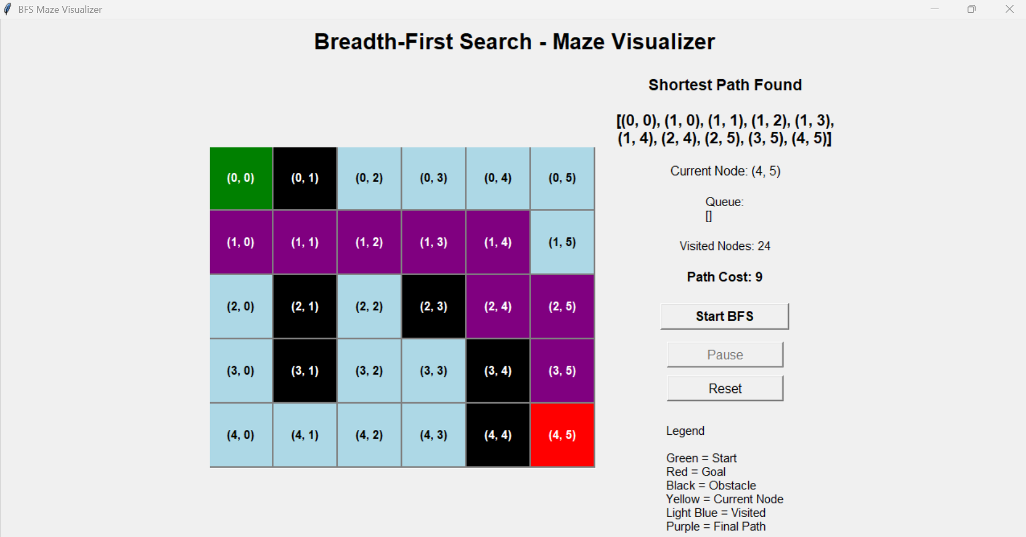
Figure 6 – Path to reach the goal

8. Logical Theory Using First-Order Logic
The maze can be expressed in the form of a knowledge base by means of First-Order Logic, with the ground facts giving specific details about the maze and the universally quantified rules outlining the general principles of movement and reasoning..

9. Ground Facts
Ground formulas include only constants and have no variables. The following ground facts represent the starting position, the goal, the obstacles and the free cells.
Start(0,0)
Goal(4,5)
Obstacle facts:
Obstacle(0,1)
Obstacle(2,1)
Obstacle(2,3)
Obstacle(3,1)
Obstacle(3,4)
Obstacle(4,4)
Examples of free-cell facts:
Free(0,0)
Free(0,2)
Free(0,3)
Free(0,4)
Free(0,5)
Free(1,0)
Free(1,1)
Free(1,2)
...
Free(4,5)
All non-obstacle nodes are represented as Free facts.

10. Universally Quantified Rules and Heuristics

10.1 Adjacency Rules
∀x∀y Adj(x,y,x,y+1) [Right]
∀x∀y Adj(x,y,x,y-1) [Left]
∀x∀y Adj(x,y,x+1,y) [Down]
∀x∀y Adj(x,y,x-1,y) [Up]

10.2 Valid Movement Rule
∀x∀y∀x1∀y1 ((Adj(x,y,x1,y1) ∧ Free(x1,y1)) → CanMove(x,y,x1,y1))
This rule states that the agent can move to a node if it is adjacent to the current node and is free.

10.3 Obstacle Rule
∀x∀y (Obstacle(x,y) → ¬Free(x,y))

10.4 Goal Rule
∀x∀y ((At(x,y) ∧ Goal(x,y)) → OutOfMaze)

10.5 Heuristic Rules
Useful preferences for intelligent movement are given by the following FOL heuristics. They are knowledge rules and not part of the blind BFS control strategy.
∀x∀y∀x1∀y1 ((CanMove(x,y,x1,y1) ∧ Closer(x1,y1,4,5)) → Prefer(x1,y1))
∀x∀y (Obstacle(x,y) → Avoid(x,y))
∀x∀y (Visited(x,y) → ¬MoveTo(x,y))

11. Group Conclusion
The Group task mainly focusses on completing Maze representation using BFS and First order logic. BFS is uninformed and blind algorithm which takes cost as 1 as each movement. Once the problem is solved, the python program was built and It helps to represent BFS and to increase the visual quality visual component was built and it shows clearly how it travers through maze find the goal.
In the next part First Order Logic was built, and it is a knowledge base mechanism.

